**Assignment (Marks 10)**

**Submit By: 3rd May 2022**

**Measuring Performance of PIG and HIVE**

**\* Only one submission per group is required**

| **Name of Group Member** | **Roll Number** |
| --- | --- |
| Archana P Ajit | MT21ACS427 |
| Christo Joseph | MT21ACS426 |
| Jishnu Chandran | MT21ACS419 |
| Rahul Nambiar | MT21ACS421 |

In this assignment, you will measure the performance of PIG and HIVE by testing them against various operations against varying sizes of data sets

The operations can be Arithmetic operation, Filter operation (filtered set 5%), Filter operation (filtered set 95%), Group of one column, Join. You can add other operations if you desire.

Sizes of the data set (increase 10X times): approx. 500 KB, 5 MB, 50 MB, 500MB, 5 GB, 50 GB

Put the code for all your operations for PIG in a single file named operationsPIG.txt and for HIVE, operationsHIVE.txt.

**Hardware configurations:**

Memory: 2GB  
Processor: 11th Gen Intel® Core™ i5-1135G7 @ 2.40GHz

Disk Capacity: 100GB

**LINK of the Data Set:**

| **Size** | **Remark** | **Link** |
| --- | --- | --- |
| 50KB | (Created From 500KB) | <https://www.kaggle.com/datasets/dansbecker/melbourne-housing-snapshot> |
| 500KB | Melbourne housing snapshot | <https://www.kaggle.com/datasets/dansbecker/melbourne-housing-snapshot> |
| 5MB | (Created from 500KB) | <https://www.kaggle.com/datasets/dansbecker/melbourne-housing-snapshot> |
| 50MB | Riots/Protests in India,2016-2022 - 100k Datapoint | <https://www.kaggle.com/datasets/shivkumarganesh/riots-in-india-19972022-acled-dataset-50k> |
| 500MB | Open Adresses US Northeast | <https://www.kaggle.com/datasets/openaddresses/openaddresses-us-northeast?select=ny.csv> |
| 5GB | Large Car Dataset | <https://www.kaggle.com/datasets/cisautomotiveapi/large-car-dataset?resource=download> |

**Fill the following table PIG:**

|  | **Size 50KB** | **Size 500KB** | **Size 5MB** | **Size 50MB** | **Size 500MB** | **Size 5GB** |
| --- | --- | --- | --- | --- | --- | --- |
| **Arithmetic Operation** | 7.811s | 6.166s | 7.334s | 7.201s | 56.147s | 106.807s |
| **Filter 5%** | 6.645s | 6.052s | 6.341s | 15.270s | 51.969s | 134.655 |
| **Filter 95%** | 6.343s | 6.078s | 6.588s | 13.237s | 53.091s | 144.899s |
| **Group By** | 7.685s | 7.236s | 9.508s | 17.461s | 105.311s | 290.718s |
| **Distinct** | 6.310s | 6.638s | 8.216s | 17.454s | 126.37s | 410.899s |
| **Join** | 6.907s | 8.749s | 94.017s | 26.471s | 192.569s | 279.977s |

**Fill the following table HIVE:**

|  | **Size 50KB** | **Size 500KB** | **Size 5MB** | **Size 50MB** | **Size 500MB** | **Size 5GB** |
| --- | --- | --- | --- | --- | --- | --- |
| **Arithmetic Operation** | 0.621 s | 0.454s | 3.079s | 0.607s | 0.519s | 186.311s |
| **Filter 5%** | 0.629s | 0.684s | 0.544s | 5.053s | 0.708s | 248.509s |
| **Filter 95%** | 0.592s | 0.578s | 0.509s | 0.798s | 0.556s | 210.602s |
| **Group By** | 29.853s | 26.863s | 34.425s | 45.27s | 57.684 s | 383.493s |
| **Distinct** | 23.276s | 23.819s | 24.176s | 33.083s | 59.88s | 425.76s |
| **Join** | 21.47s | 27.61s | 174.328s | 38.455s | 113.668s | 500.15s |

**Graph:**

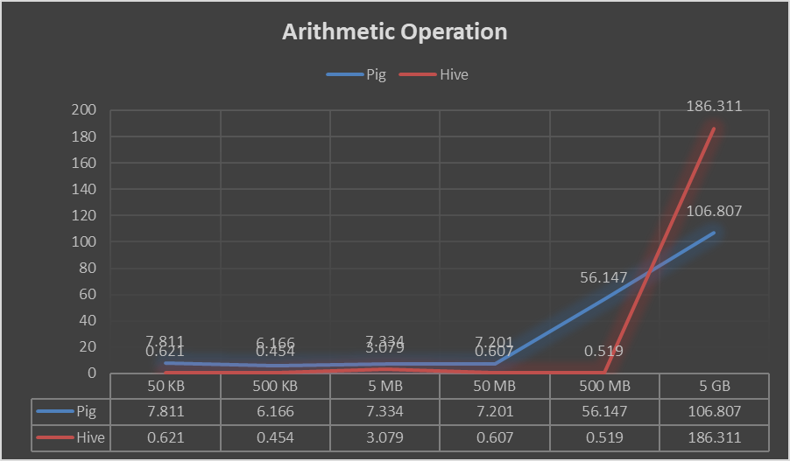

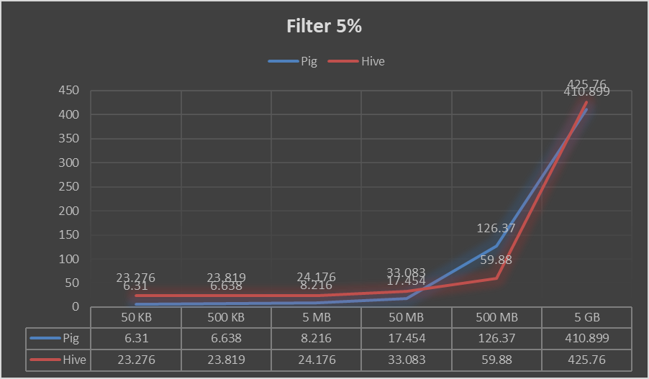

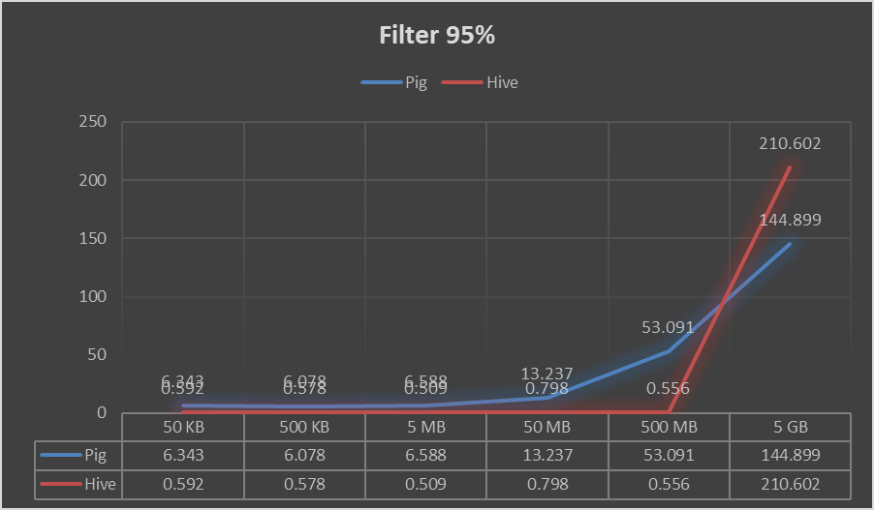

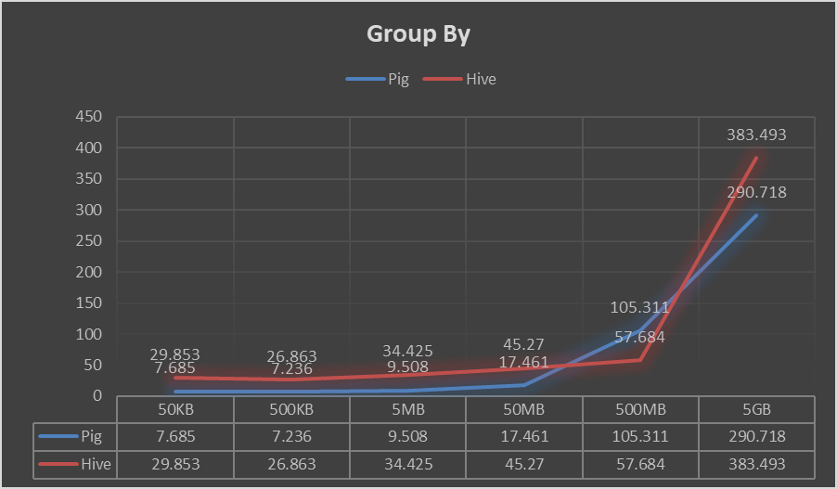

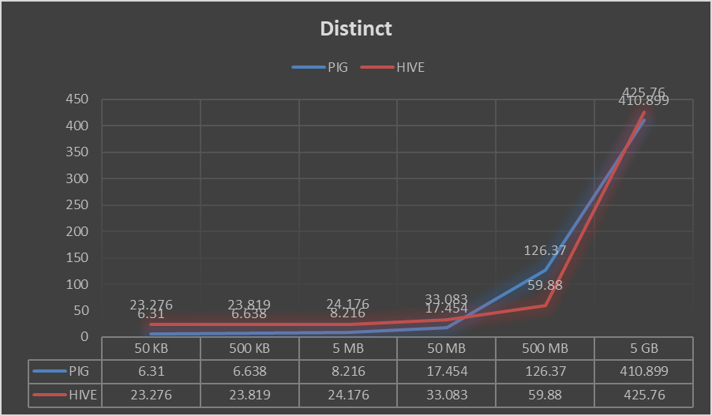

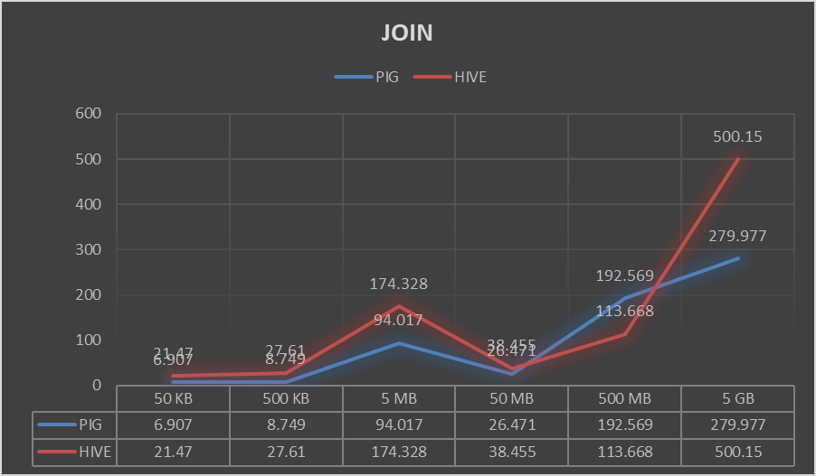

**Conclusion:**

As per the above result we can conclude the following:

* Hive performed slightly better than Pig in case of arithmetic operations.
* Overall Pig performance is better than Hive for filtering 5% of the dataset.
* Overall Pig performance is better than Hive for filtering 95% of the dataset.
* Pig performance is dominating over Hive for Group By operation.
* Pig performance seems to be better than Hive for Distinct operation.
* Overall Pig performance is better than Hive for Join operation.

In conclusion, Pig performs better when compared to Hive in case of varying size of datasets.